Geography Rap
By: Miss Baumgartner
There are two Americas, North and South,
If you didn’t know that, open your mouth.
North America’s a group of three.
Let’s learn the names of each country.
We live in the USA.
United States is what we say.
Up north it’s cold and we don’t want that,
So Canada serves as America’s hat!
Down south there’s a country that’s shaped kind of weird.
We call that Mexico, America’s beard!
Go to the west if you get the notion,
You’ve gone too far if you hit the ocean.
Which ocean is it? We must be specific,
This ocean is named-- the Pacific.
If you go east and see the commotion,
You can also see the Atlantic Ocean.
We’re in second grade but we’re mighty smart.
We’re learning geography part by part.

2

3

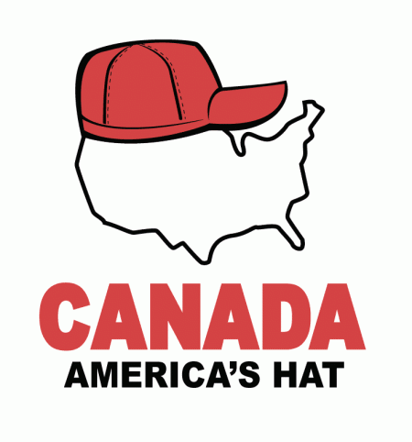
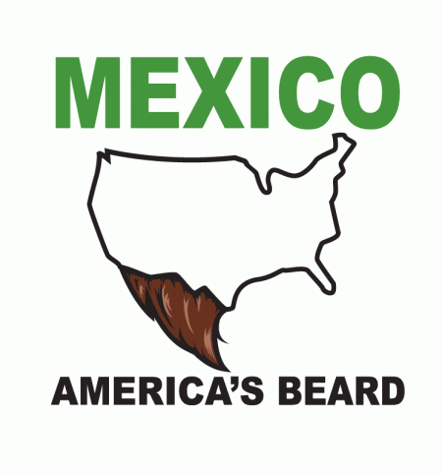

WEST

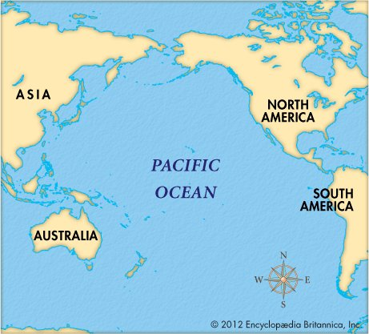

EAST
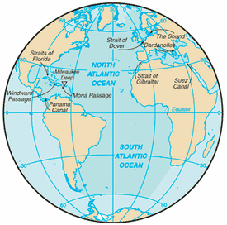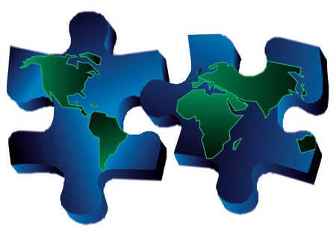

Name:

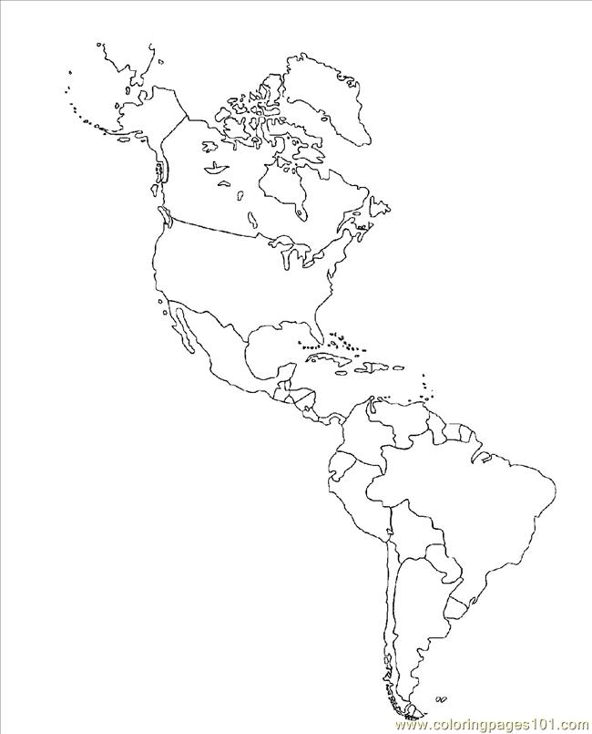
Word Bank
- South America
- Canada
- North America
- The United States
- Pacific Ocean
- Atlantic Ocean
- Mexico

