[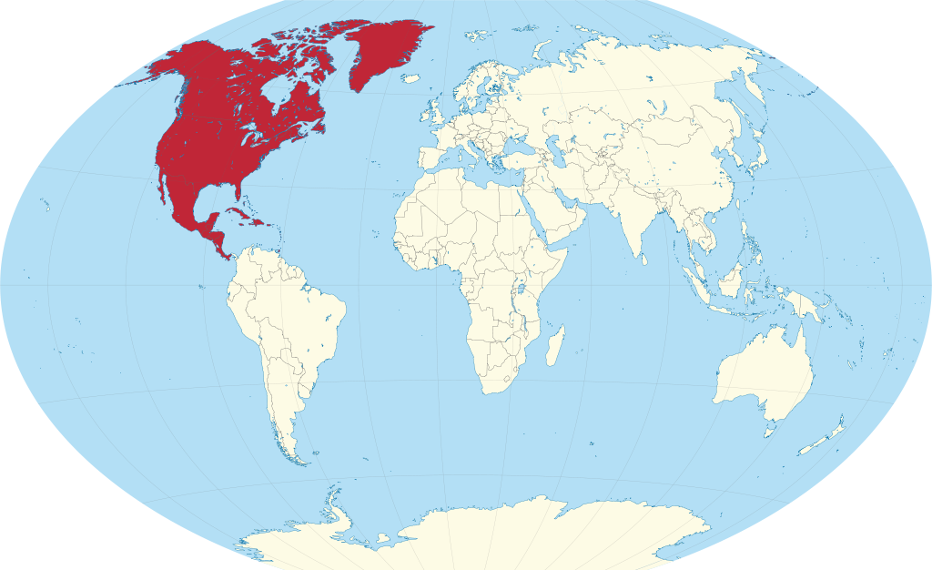](https://www.google.com/url?sa=i&rct=j&q=&esrc=s&source=images&cd=&cad=rja&uact=8&ved=0ahUKEwiyy665tZjMAhXHm4MKHf02D0UQjRwIBw&url=https%3A%2F%2Fcommons.wikimedia.org%2Fwiki%2FFile%3ANorth_America_in_the_world_(red)_(W3).svg&bvm=bv.119745492,d.amc&psig=AFQjCNG459wF8HK8As1nEMzCORXe2uSGNw&ust=1461076748067946)

North America

Rocky Mountain Rock Wall

[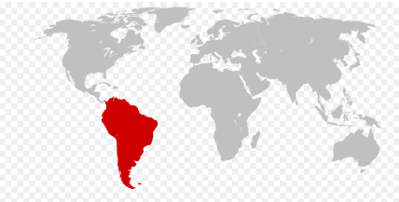](http://www.google.com/url?sa=i&rct=j&q=&esrc=s&source=images&cd=&cad=rja&uact=8&ved=0ahUKEwi65rGOtJjMAhUBr4MKHccNAOMQjRwIBw&url=http%3A%2F%2Fwww.kidsmaps.com%2Fgeography%2Fsouth%2Bamerica%2FTopographic%2FMap%2Bof%2BSouth%2BAmerica&bvm=bv.119745492,d.amc&psig=AFQjCNGhXlVSxMuFy_adavN7gsLfcEHv2A&ust=1461076452292996)

South America

Amazon Rainforest Vine Swing

[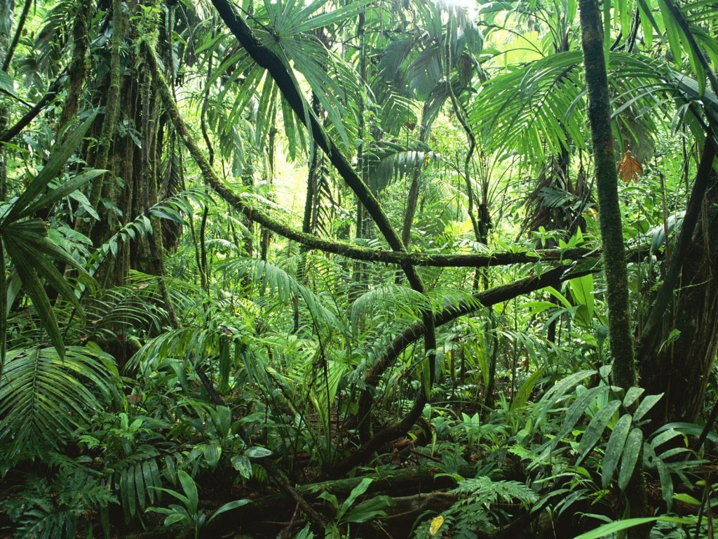](http://www.google.com/url?sa=i&rct=j&q=&esrc=s&source=images&cd=&cad=rja&uact=8&ved=0ahUKEwjyy8X8uJjMAhUBlYMKHQ-OBgcQjRwIBw&url=http%3A%2F%2Fedugeography.com%2Fcontent%2Famazon-rainforest.html&bvm=bv.119745492,d.amc&psig=AFQjCNE8KCLd2yyHC9KDwS3twmqYqX2SRw&ust=1461077706284694)

[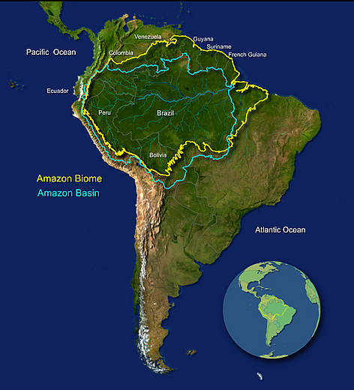](http://www.google.com/url?sa=i&rct=j&q=&esrc=s&source=images&cd=&cad=rja&uact=8&ved=0ahUKEwjerOfluJjMAhXmnYMKHUVZC4EQjRwIBw&url=http%3A%2F%2Fwwf.panda.org%2Fwhat_we_do%2Fwhere_we_work%2Famazon%2Fabout_the_amazon%2F&bvm=bv.119745492,d.amc&psig=AFQjCNFlEjyM-2TH2uYrgDka5-Kfs46nfA&ust=1461077711808759)

Amazon Rainforest

[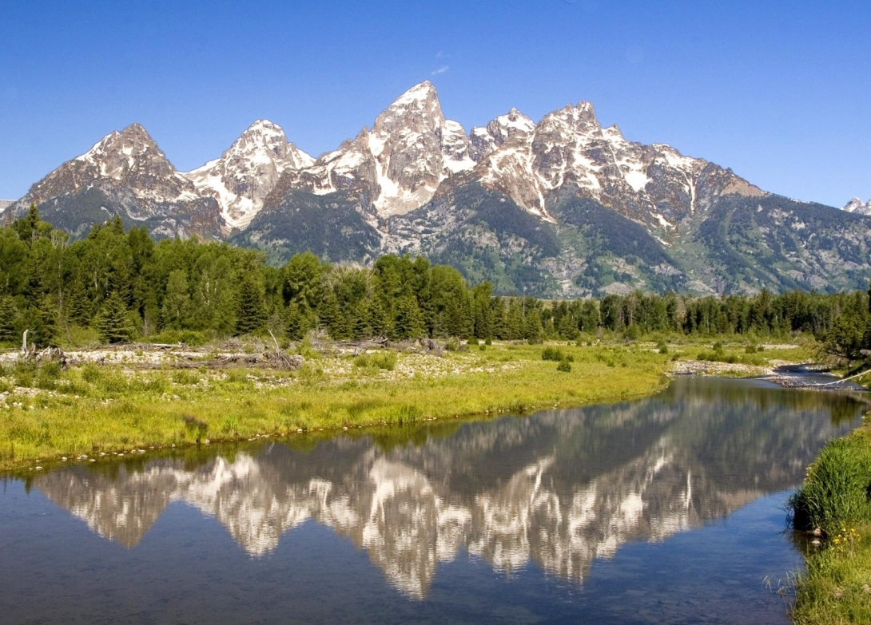](http://www.google.com/url?sa=i&rct=j&q=&esrc=s&source=images&cd=&cad=rja&uact=8&ved=0ahUKEwio9a77tpjMAhVImIMKHSDfB6QQjRwIBw&url=http%3A%2F%2Fwww.destination360.com%2Fnorth-america%2Fus%2Fwyoming%2Frocky-mountains&bvm=bv.119745492,d.amc&psig=AFQjCNFmkINm4_BVp42BRSqKCp1ehr5lcw&ust=1461077214283270)[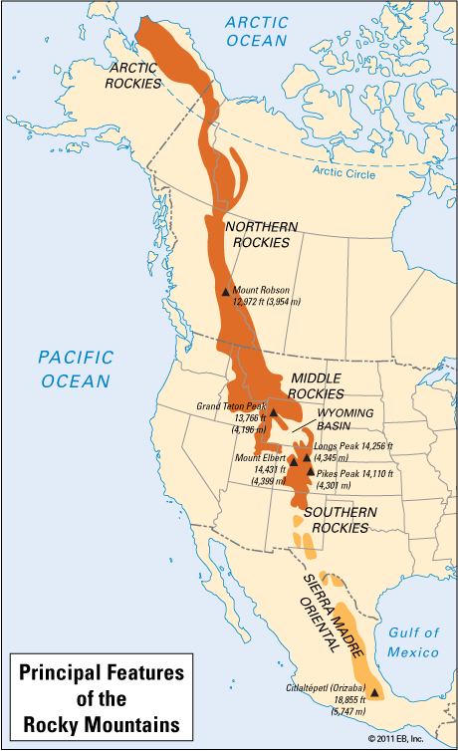](http://www.google.com/url?sa=i&rct=j&q=&esrc=s&source=images&cd=&cad=rja&uact=8&ved=0ahUKEwjv7ZLhtpjMAhVhn4MKHRYrD3AQjRwIBw&url=http%3A%2F%2Fkids.britannica.com%2Fcomptons%2Fart-166612&bvm=bv.119745492,d.amc&psig=AFQjCNGNrX12GnxNMySWVHcOYjSEiD-nqQ&ust=1461077166051188)

The Rocky Mountains

[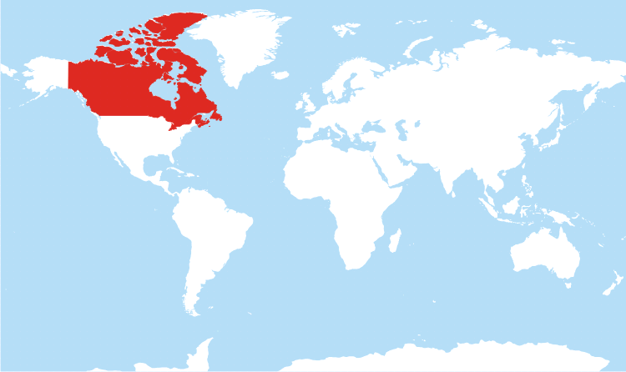](http://www.google.com/url?sa=i&rct=j&q=&esrc=s&source=images&cd=&cad=rja&uact=8&ved=0ahUKEwjt3rqztJjMAhViuIMKHZ_oDMEQjRwIBw&url=http%3A%2F%2Fwww.freeworldmaps.net%2Fnorthamerica%2Fcanada%2Flocation.html&bvm=bv.119745492,d.amc&psig=AFQjCNGLdcu17fTICNNt0qT2tr6PK5qysA&ust=1461076538034472)

Canada

Log Roll

[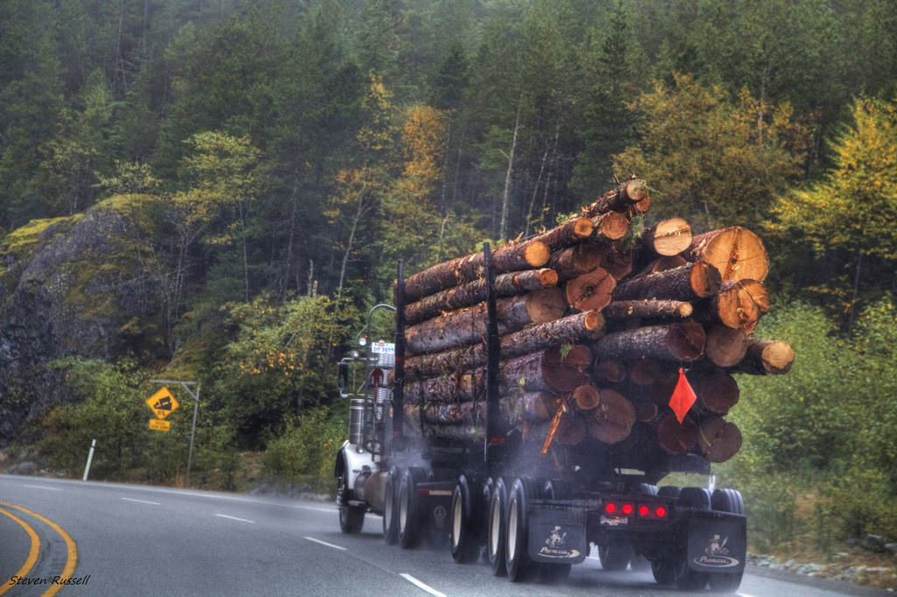](https://www.google.com/url?sa=i&rct=j&q=&esrc=s&source=images&cd=&cad=rja&uact=8&ved=0ahUKEwiQ_NHQt5jMAhUEkIMKHTH0DIEQjRwIBw&url=https://www.flickr.com/photos/29564546@N07/8505323017&bvm=bv.119745492,d.amc&psig=AFQjCNGc3FthBQs3Dgyo9pDg0bCYcVzPoQ&ust=1461077397900195)

Canadian Logging

[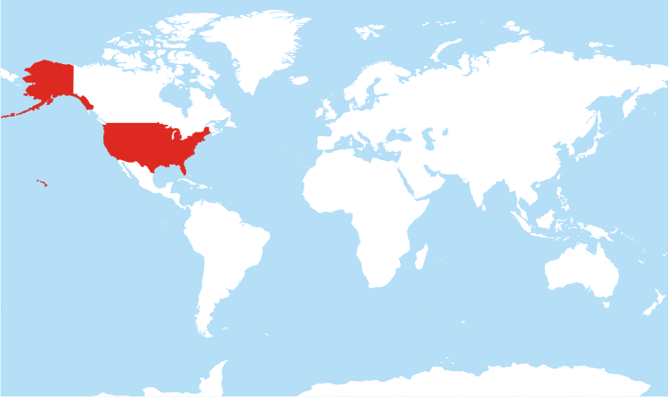](http://www.google.com/url?sa=i&rct=j&q=&esrc=s&source=images&cd=&cad=rja&uact=8&ved=0ahUKEwijv9zNtJjMAhUmyYMKHeJpARoQjRwIBw&url=http%3A%2F%2Fwww.freeworldmaps.net%2Fnorthamerica%2Funited-states%2Flocation.html&bvm=bv.119745492,d.amc&psig=AFQjCNF4NjBpH9H0pZrY5iKYvnbAhiN_zg&ust=1461076593012454)

United States of America

Pony Express Gallop

[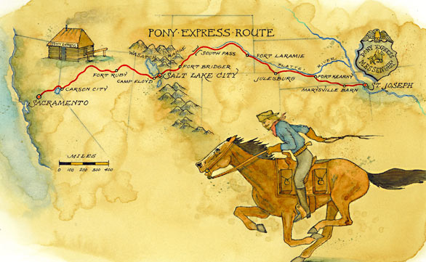](http://www.google.com/url?sa=i&rct=j&q=&esrc=s&source=images&cd=&cad=rja&uact=8&ved=0ahUKEwjCt9LDvZjMAhWivYMKHWzGCUoQjRwIBw&url=http%3A%2F%2Farticles.latimes.com%2F2010%2Fmay%2F16%2Ftravel%2Fla-tr-ponyexpress-20100516&psig=AFQjCNEGzpi5dCebxaJPPUxWVpigGwn-8Q&ust=1461078987539060)

Pony Express Route

[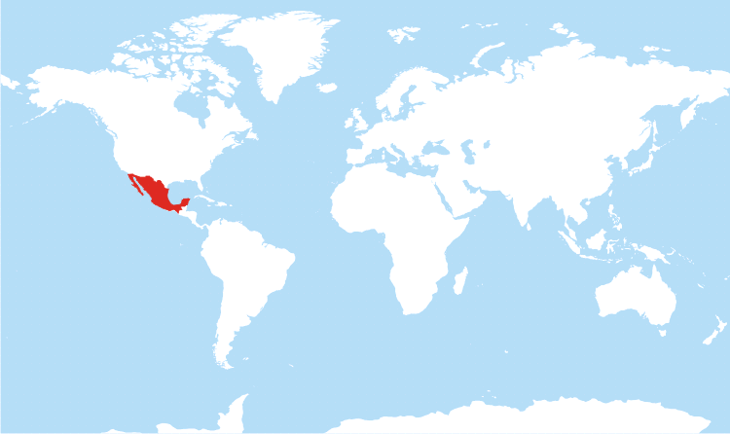](http://www.google.com/url?sa=i&rct=j&q=&esrc=s&source=images&cd=&cad=rja&uact=8&ved=0ahUKEwi-j978tJjMAhWGgYMKHYw9BfUQjRwIBw&url=http%3A%2F%2Fwww.freeworldmaps.net%2Fnorthamerica%2Fmexico%2Flocation.html&bvm=bv.119745492,d.amc&psig=AFQjCNGdb_lu_FKJUB9sE8cx3aawkTYnew&ust=1461076693610100)

Mexico

Chichen Itza Hike

[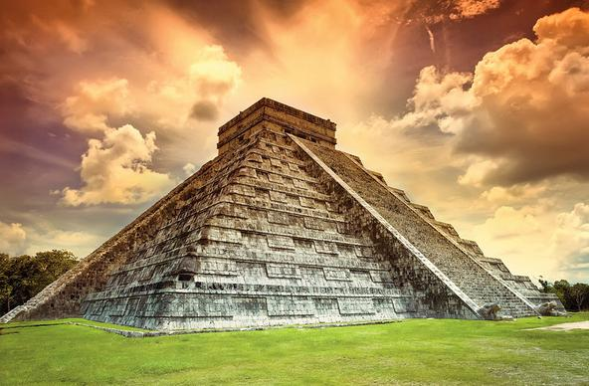](http://www.google.com/url?sa=i&rct=j&q=&esrc=s&source=images&cd=&cad=rja&uact=8&ved=0ahUKEwiWnYjut5jMAhXpzoMKHb_TClcQjRwIBw&url=http%3A%2F%2Flunamayadmc.com%2Fen%2Fproducto%2Fchichen-itza-seventh-wonder-of-the-world%2F&bvm=bv.119745492,d.amc&psig=AFQjCNHzbgh96qdk_obaIlnCTuqWmYjcHA&ust=1461077463209317)

Chichen Itza

[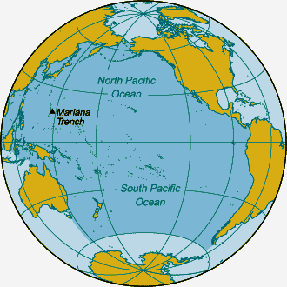](http://www.google.com/url?sa=i&rct=j&q=&esrc=s&source=images&cd=&cad=rja&uact=8&ved=0ahUKEwinm7b_tZjMAhVKs4MKHQdHBHkQjRwIBw&url=http%3A%2F%2Fwww.bluebird-electric.net%2Foceanography%2Fpacific_ocean.htm&bvm=bv.119745492,d.amc&psig=AFQjCNFHFYST7Pxk2uSdUwG9cKrvvUclCQ&ust=1461076949000667)

Pacific Ocean

Island Hop

[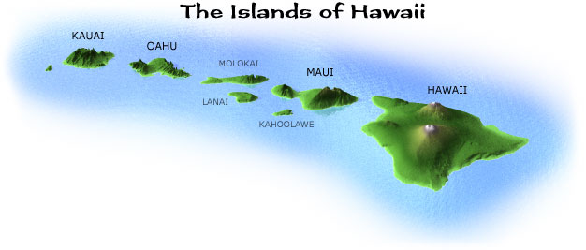](http://www.google.com/url?sa=i&rct=j&q=&esrc=s&source=images&cd=&cad=rja&uact=8&ved=0ahUKEwjy2urnuZjMAhXBkIMKHRNbCCYQjRwIBw&url=http%3A%2F%2Fwww.bestplaceshawaii.com%2Fmaps%2F&bvm=bv.119745492,d.amc&psig=AFQjCNGpr4pcgO0FwPZ_IBTZxCHLv1bdoQ&ust=1461077991074102)

[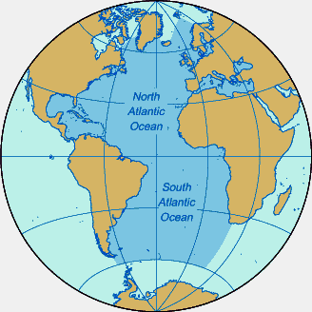](http://www.google.com/url?sa=i&rct=j&q=&esrc=s&source=images&cd=&cad=rja&uact=8&ved=0ahUKEwiCvP6ptpjMAhWqkYMKHW-cB8MQjRwIBw&url=http%3A%2F%2Fwww.bluebird-electric.net%2Foceanography%2Fatlantic_ocean.htm&bvm=bv.119745492,d.amc&psig=AFQjCNFAO4qyHWVra7mC_QliKw58Qfpcqg&ust=1461077052180772)

Atlantic Ocean

Atlantic Bridge Walk

[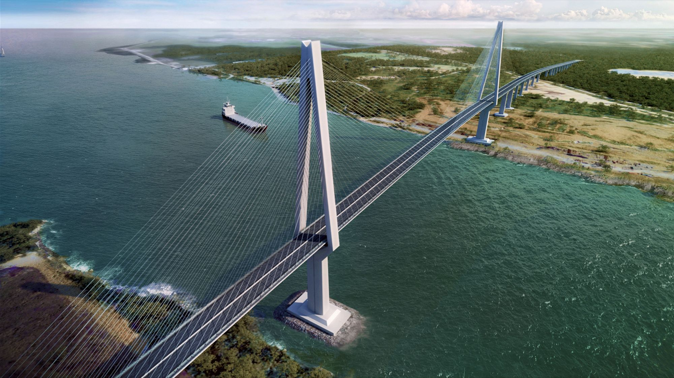](http://www.google.com/url?sa=i&rct=j&q=&esrc=s&source=images&cd=&cad=rja&uact=8&ved=0ahUKEwj10NeaupjMAhUDyYMKHebrAJEQjRwIBw&url=http%3A%2F%2Fwww.cgarchitect.com%2F2013%2F07%2F3th-panama-bridge&bvm=bv.119745492,d.amc&psig=AFQjCNHbhNGcObUped-kp2jeUYNL1Q833g&ust=1461078064495280)

Atlantic Bridge in Panama